



To all concerned parties!

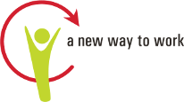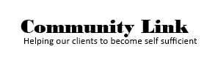

For questions regarding **CCMEP OWF** customers

or if you have an immediate need,

please contact us

**CCMEP Program**

**513-509-7981 or 513-482-4600**

**Fax: 513-381-1289**

**Announcement:**

Effective July 1, 2020, Community Link will no longer be servicing the Ohio Works First 18-24-year-old population. The CCMEP Program will provide all services for this population.

The new location is the CCMEP office at 644 Linn St, Suite 600, Cincinnati, Ohio 45203.

As we work to ensure a smooth transition, here are a few items to know:

1. All participation documentation for June & July should be submitted to the CCMEP office at 644 Linn Street, Suite 600, Cincinnati, Ohio 45203 or **faxed to**

**(513)381-1289**

1. Transportation assistance for June & July can be picked up from the CCMEP office, 644 Linn Street, Suite 600, Cincinnati, Ohio 45203.
2. The computer lab will move to 644 Linn Street, Suite 626 and be open on July 1,2020
3. Your new CCMEP case manager will contact you by July 13,2020 to provide you an update on the transition.
4. Community providers are welcome to call us at the numbers listed below